**Exercise 3**

**For 1, 2, 3, 4, 5, 6:**

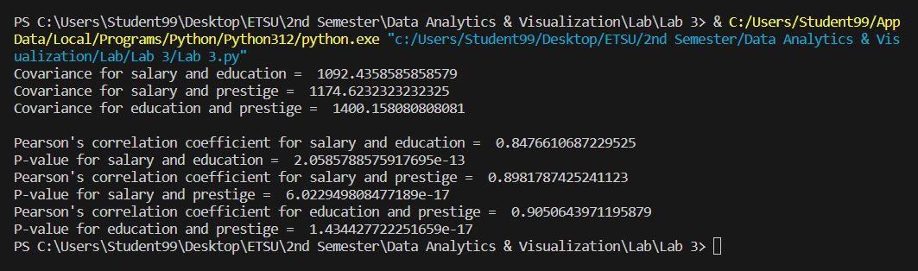

**For 7:**

For salary and education:

1. Strength – Strong correlation as it lies between 0.8 – 0.9
2. Direction – Positive correlation i.e., if salary increases then education also increases and vice versa
3. Statistical Significance – Yes, the correlation test can be trusted as its value is less than 5% (i.e., 0.05). This indicates that the likelihood for having the wrong data for salary and education is 2.0585788575917695e-13.

For salary and prestige:

1. Strength – Strong correlation as it lies between 0.8 – 0.9
2. Direction – Positive correlation i.e., if salary increases then prestige also increases and vice versa
3. Statistical Significance – Yes, the correlation test can be trusted as its value is less than 5% (i.e., 0.05). This indicates that the likelihood for having the wrong data for salary and prestige is 6.022949808477189e-17.

For education and prestige:

1. Strength – Strong correlation
2. Direction – Positive correlation i.e., if education increases then prestige also increases and vice versa
3. Statistical Significance – Yes, the correlation test can be trusted as its value is less than 5% (i.e., 0.05). This indicates that the likelihood for having the wrong data for education and prestige is 1.434427722251659e-17.

**For 8:**

Although Pearson’s correlation coefficient and covariance both can be used to measure the direction of the relationship between two variables, Pearson’s correlation coefficient is considered a better measure because of its standardization in terms of measurement scale.

In other words, the covariance of two variables differs in size (or amount) when their measuring units are altered (for example: meter to inch, Kg to Lb., etc.). This creates a problem in visualizing the amount of correlation between two variables, whereas Pearson’s correlation coefficient is not impacted in this case. The value of Pearson’s correlation coefficient is the same for all the measuring units.